

**AMERICAN INTERNATIONAL UNIVERSITY–BANGLADESH (AIUB)**

**Spring 2025**

**BUSINESS COMMUNICATION [FST/FE] [B]**

**REPORT**

***Data Privacy and Awareness: A Study Among Users of e-Commerce Platform in Bangladesh***

***Submitted To:***

***Tasnia Tarannum***

***Submitted by:***

|  |  |  |
| --- | --- | --- |
| NAME | ID | CONTRIBUTION |
| MD. Abrar Rafid Shariar | 22-48055-2 | |
| S.M. Rasel | 22-48039-2 |  |
| MD. Al – Imran Sayem | 22-48023-2 |  |
| MD. Tanjil Tashrik Zim | 22-48021-2 |  |

***Data Privacy and Awareness: A Study Among Users of***

***e-Commerce Platform in Bangladesh***

*Abstract*—This report aims to investigate data privacy awareness and concerns among users of e-commerce platforms in Bangladesh. The study involved surveying 56 participants using multiple-choice questions to evaluate their knowledge and behaviors regarding data collection during online purchases. A Google Form was used as the data collection tool. Results from the survey show that 71.4% of respondents are aware their personal data is collected. However, 35.7% have never read any privacy policy, mainly due to complexity and length. Furthermore, 37.5% expressed concern about data misuse, and 25% reported experiencing or suspecting a privacy breach. The study highlights the importance of increasing user awareness and implementing clearer data protection practices on Bangladeshi e-commerce platforms.

**Keywords: E-commerce; Data Privacy; Data Awareness.**

INTRODUCTION

**A. Background and Context**

The rapid growth of e-commerce has revolutionized the way businesses and consumers interact, leading to the digitalization of global trade and the establishment of virtual marketplaces [1]-[3]. Online shopping has become an essential part of modern commerce, offering consumers the convenience of purchasing goods and services from anywhere in the world. According to the latest global statistics, e-commerce has seen exponential growth, with the global retail e-commerce sales expected to surpass $7 trillion by 2025.However, there are issues with this rapid expansion as well, particularly with data privacy. Personal data such as names, addresses, and bank account information are gathered by online retailers. Inadequate protection of this data makes it vulnerable to theft and exploitation [4], [5]. Many people are not entirely aware of how their data is used or how to protect it. According to a survey, even though many people are aware of the hazards, they still fail to take adequate precautions to safeguard their personal information [6]. Therefore, it's critical that consumers and businesses understand and take seriously online privacy.

**B. Review of Existing Work**

**C. Research Gap**

While numerous studies have examined data privacy issues in the context of global e-commerce, there is limited research focused specifically on user awareness and privacy concerns within the Bangladeshi e-commerce landscape. Existing literature often emphasizes technical solutions for data protection or focuses on broader cybersecurity frameworks. However, there is a lack of empirical evidence on how Bangladeshi users perceive data privacy, their understanding of privacy policies, and their behavior when sharing personal information online. Moreover, user-level awareness, emotional response to privacy threats, and practical engagement with data protection practices remain underexplored. This study seeks to fill this gap by focusing on the knowledge, perceptions, and attitudes of e-commerce users in Bangladesh regarding personal data privacy.

**D. Research Objectives**

This study aims to investigate data privacy concerns and awareness levels among users of e-commerce platforms in Bangladesh by focusing on the following objectives:

* To assess the level of awareness among Bangladeshi e-commerce users regarding the personal data collected during online transactions.
* To examine how well users understand and engage with the privacy policies provided by e-commerce platforms in Bangladesh.
* To identify the types of personal data most commonly shared by users on Bangladeshi e-commerce platforms.
* To explore users’ perceptions and concerns about the risks of data theft or misuse during online shopping.

E. **Overview**

1. **Methodology**

A. Research Design

This study used surveys to learn about data privacy awareness among online shoppers in Bangladesh. We collected information directly from Bangladeshi people who regularly shop online to understand their thoughts and concerns about privacy. The main goal was to find out what online shoppers know about how companies collect their personal information, whether they read privacy policies, and how worried they are about their data being misused when shopping online.

B. Setting and Sampling

The survey was conducted online over a two-week period. Participants were recruited through voluntary sampling, targeting Bangladeshi users of various e-commerce platforms. In total, 55 responses were collected. The sample included individuals from diverse age groups, genders, and educational backgrounds to ensure a broad representation of e-commerce users in Bangladesh

C. Data Collection Methods

We collected data using Google Forms with multiple-choice questions to get clear and measurable answers. The survey had four main parts: basic information about participants, how much they know about data collection, their understanding of privacy policies, how they share personal information, and their worries about data privacy.

D. Data Analysis Procedures:

The collected data was compiled and analyzed using descriptive statistics, including percentages and frequency distributions, to identify key trends and patterns related to data privacy awareness and concerns among Bangladeshi e-commerce users. We compared different groups of people (like age and gender) to see how their privacy awareness levels differed from each other.  
  
E. Ethical Considerations

Participation in the survey was entirely voluntary and anonymous. Respondents were informed about the purpose of the study and assured that their responses would remain confidential. No personally identifiable information was collected, and all data was used solely for academic research purposes, adhering to ethical standards for privacy and informed consent

.

1. Results

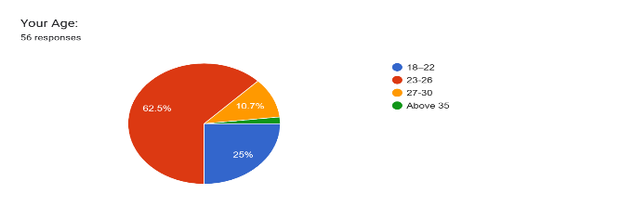

Fig 1: Age of the participants

Figure 1 shows the age distribution of the 56 respondents who participated in this survey. The majority (62.5%) are between the ages of 23–26, indicating that most online shoppers in the sample are young adults. Additionally, 25% of respondents fall in the 18–22 age group, followed by 10.7% in the 27–30 range. Only 1.8% of participants are above 35. This suggests that e-commerce usage is particularly common among individuals in their early to mid-twenties, who may be more tech-savvy and engaged in digital commerce.

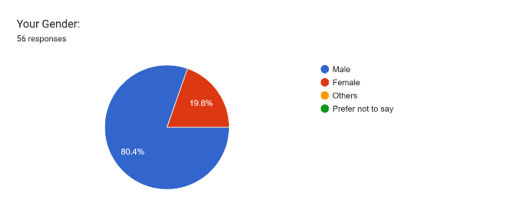

Fig 2: Gender of the participants

Figure 2 illustrates the gender distribution of participants. A significant majority (80.4%) identified as male, while 19.6% identified as female. No respondents selected "Others" or "Prefer not to say". This indicates a notable gender imbalance in the survey sample, which may reflect either a greater engagement of males with online shopping in this context or a sampling bias. Future studies may aim for a more balanced gender representation to better generalize findings.

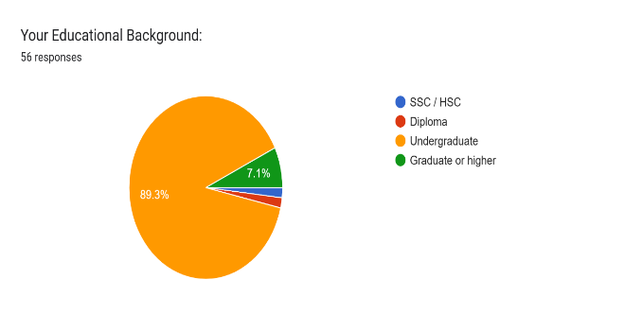

Fig 03: Educational background of the participants

Figure 3 highlights the educational background of the participants. A large majority (89.3%) of respondents are currently enrolled in undergraduate programs, while 7.1% have completed graduate-level education. A very small portion of the sample has SSC/HSC or diploma-level education. The dominance of undergraduate students suggests that younger, educated individuals form the core of Bangladesh’s e-commerce user base, aligning with national trends in youth-driven digital adoption.

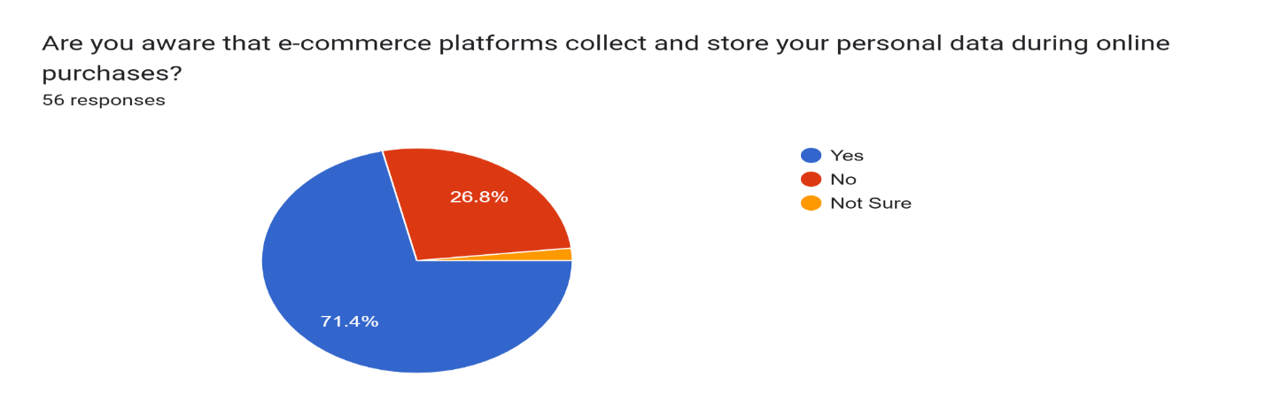

Fig 04: Awareness of Data Collection by E-commerce Platforms

Figure 4 reveals participants' awareness of data collection practices by e-commerce platforms. A considerable 71.4% indicated they are aware that their personal data is collected during online transactions, whereas 26.8% responded negatively and 1.8% were unsure. This result indicates that while awareness is relatively high, nearly 1 in 3 users still lack a clear understanding of how their information is being utilized, signifying a critical area where privacy education must be improved.

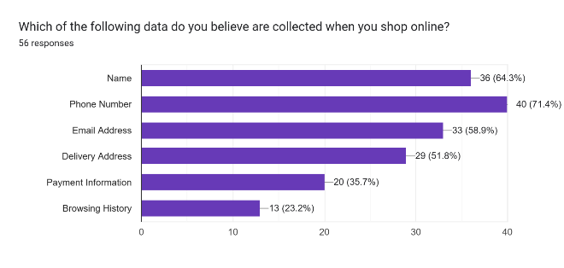

Fig 05: Types of Data Believed to be Collected by E-commerce Platforms

Figure 5 shows the types of data respondents believe are collected when shopping online. The majority (71.4%) indicated phone numbers are collected, followed by names (64.3%) and email addresses (58.9%). Delivery addresses (51.8%) and payment information (35.7%) were also noted. Interestingly, only 23.2% believed browsing history is collected. This suggests that users are more aware of direct data input (like name and phone number) but less informed about passive data collection practices such as browsing behavior.

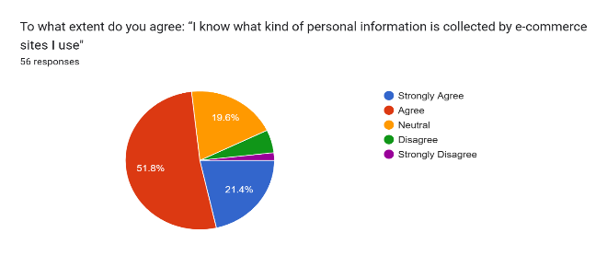

Fig 06: Self-awareness About Data Being Collected

Figure 6 explores users' self-assessed awareness of what personal information is collected by e-commerce sites. Over half (51.8%) agreed with the statement, while 21.4% strongly agreed. However, 19.6% remained neutral, and 7.1% disagreed or strongly disagreed. This indicates a generally moderate level of awareness, though a significant portion of users still lacks full clarity on the specifics of data being collected.

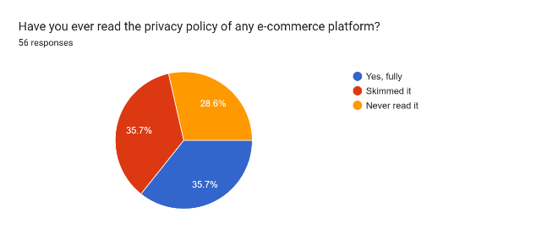

.

Fig 7 : Experience with Reading Privacy Policies.

Figure 7 shows whether respondents have read the privacy policies of e-commerce platforms. The results are evenly distributed, with 35.7% saying they have read fully, another 35.7% having only skimmed, and 28.6% admitting to never reading them. This balanced result reflects a lack of consistent engagement with privacy documents and highlights a potential vulnerability regarding informed consent.

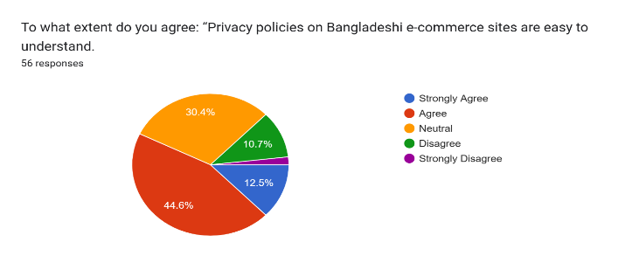

Fig 8: Clarity of Privacy Policies According to Users

Figure 8 presents respondents’ perceptions regarding the understandability of privacy policies. Only 12.5% strongly agreed they were easy to understand, and 44.6% simply agreed. However, 30.4% remained neutral, while 10.7% disagreed and 1.8% strongly disagreed. The responses indicate that while some find these policies somewhat clear, a substantial portion either does not find them user-friendly or lacks a strong opinion due to limited exposure.

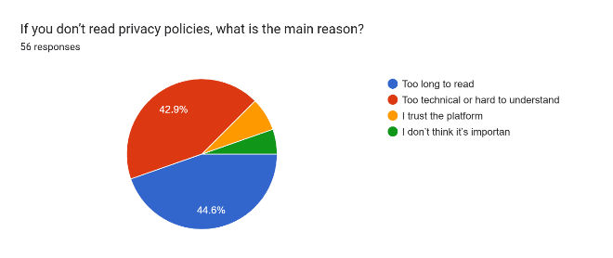

Fig 9 : Reasons for Not Reading Privacy Policies

Figure 9 reveals the primary reasons respondents avoid reading privacy policies. The most common reason, selected by 44.6%, was that they are too long. This is followed closely by 42.9% who find them too technical or difficult to understand. A smaller number trust the platform or don’t find the policy important. These results emphasize that simplifying privacy policies could encourage more users to read and engage with them.

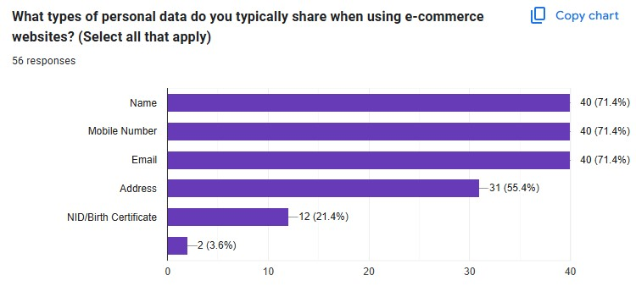

Fig 10: Types of Personal Data Shared

The survey reveals that users most frequently share basic personal data like name, mobile number, and email (71.4% each) on e-commerce platforms, while fewer disclose sensitive details like NID/birth certificate (21.4%). This suggests a tendency to prioritize convenience over privacy, despite potential risks. The high sharing of contact information highlights vulnerabilities to spam or phishing. E-commerce platforms should implement stricter data protection measures and educate users on safeguarding sensitive data. Addressing this gap is critical for enhancing trust and security in Bangladesh’s digital marketplace.